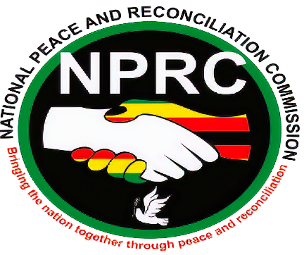

REQUEST FOR QUOTATION
The National Peace and Reconciliation Commission invites all registered companies to make a firm offer for the provision of the following services:
Procurement reference number | Description of Requirements | Quantity | Closing date and time
RFQ0821 | - Request for quotation for quotations for the follows with :  - Branded Golf T-Shirts ( Logo and message )  - Branded Round neck T.Shirts ( Logo and message )  - Branded Caps ( Logo and message )  - Branded Face mask ( Logo and Message ) | 50  150  150  100 | Friday 10 September 2021
1

Commercial terms
- Bidders must have current (2021) PRAZ Registration certificate and must submit it
- Bidders must have ZIMRA registration and must submit tax clearance and VAT certificate
- Bidders must have a vendor number and must confirm in their submissions the vendor number

Instruction to bidders
- Quotations must be priced in ZWL
- Prices must include material cost, labour, taxes and any other variable costs that adds up to the total cost of the items being offered.
- The lowest quote to specifications will be awarded the contract.

The quotations must be submitted via email to mmudeke@nprc.org.zw Cc mchinyadza@nprc.org.zw
Contact details 0719 527 625/0773854543

