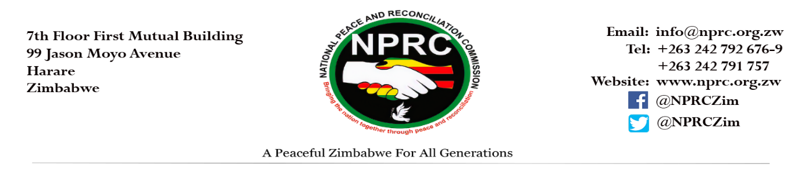
National Peace and Reconciliation Commission
2021 International Day of the Girl Child Commemorative Statement
11 October 2021

On this day, 11 October 2021, the National Peace and Reconciliation Commission joins the rest of the world in commemorating the International Day of the Girl Child running under the theme "Digital generation. Our generation."
As the Commission executes its constitutional mandate to resolve the burdens of past violent conflicts and building national and sub-national capacities to guarantee a future of peace and reconciliation, the NPRC is mandated by section 9 of the NPRC Act to ensure the participation of all groups of people including girls in all its work.
The NPRC recognises that adolescent girls’ experiences of peace, conflict and violence are different from those of younger children, boys, men and even adult women. The unique intersection of age and gender makes adolescent girls particularly vulnerable to physical, emotional, sexual, and mental health issues and disproportionately high levels of sexual and gender-based violence. During times of crises and conflict, adolescent girls are more likely to be forced out of school, hence increasing their vulnerability to forced, early and child marriages amongst other violations. These realities for girls, especially those living in conflict or crisis situations are further compounded by poor access to internet, electricity and other information communication technologies to enable their right to education and access to information.
Additionally, due to the COVID 19 pandemic, the levels of conflict continue to escalate, calling for the need to transit from reactive and response approaches towards adoption of more robust and preventive approaches where girls fully participate to attain and maintain peace during and post the pandemic period. The 2021 International day of the girl child theme therefore solidifies the importance of digital literacy and connectivity in the advent of the COVID 19 pandemic and as Zimbabwe and the world at large recover from the COVID 19 pandemic. To ensure the participation of girls in peace building post COVID 19 pandemic, there is therefore need to take into account the diverse digital realities that girls face and the ways in which these can deepen the gender divide around connectivity, skills and safety from violence.
Vis-a -Vis, peace in communities is a key ingredient to ensure that girls enjoy their rights to technology, a safe, educated, and healthy life, not only during the girl child’s critical formative years, but also as they mature into women. If effectively supported through peaceful communities during the adolescent years, girls have the potential to change the world – as the empowered girls of today, as tomorrow’s leaders and as drivers of peaceful societies.

The NPRC thus calls for all relevant stakeholders to put girls at the heart of the digital revolution by supporting initiatives that include digital access and the development of digital skills; investing in technology and innovation for social cohesion and the designing of new tools to prevent and eliminate online and tech-facilitated violence.

Through access to technology, it is possible to make adolescent girls visible, and recognise the powerful role girls can play in creating peaceful and safe societies. Let us therefore work together to ensure that girls are connected, supported and empowered to co-lead the journey of digital transformation!!!!!

