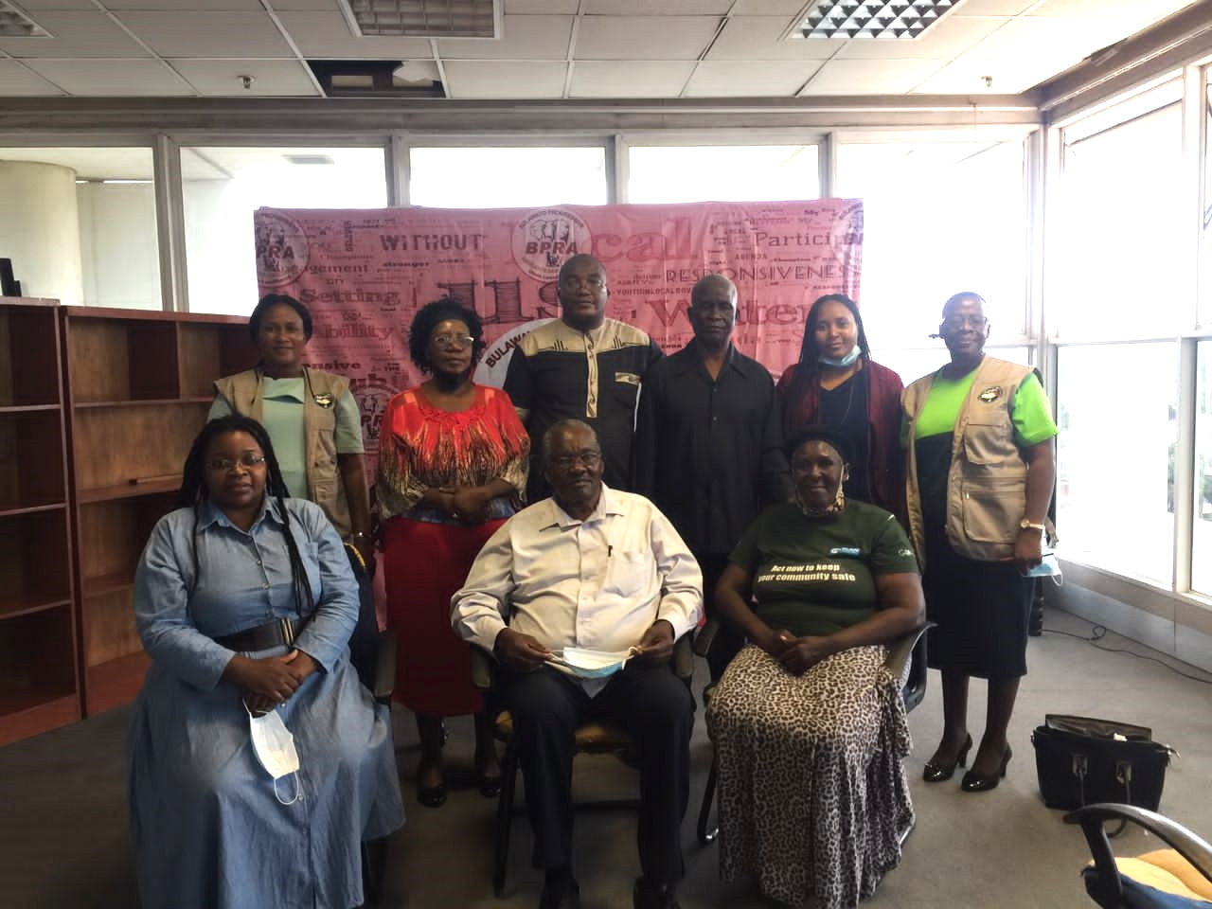NPRC Chairperson Retired Justice Selo Masole Nare, Commissioner Nomaqhawe Gwere, Executive Secretary Mrs Sibusisiwe Zembe & Bulawayo Progressive Residents Association Executive Council representatives.

NPRC calls for peaceful By-Elections
The National Peace and Reconciliation Commission embarked on a Voter Peace Education Campaign which was conducted in two phases. The first phase commenced on the 15th to 18th February 2022 while the second one kicked off on the 14th ^{to} the 19th March 2022. The Commission deployed teams to the country’s ten provinces to conduct Voter Peace Education. The campaign emphasised the importance of preserving peace before, during and after elections. Targeted areas were those where the March 26 by-elections would take place. The teams took the opportunity to assess the level of peacefulness in the country with a view to minimise and to prevent conflicts and violence. The main objective of the campaign was to promote a peaceful and friendly environment which embraces diversity before, during and after the election period.
The teams paid courtesy calls on the Commission’s critical stakeholders such as the Zimbabwe Republic Police (ZRP), Zimbabwe Electoral Commission (ZEC), State Security, Traditional Leaders, Civil Society Organisations and various stakeholders. The Commission had an opportunity to familiarise with communities and community leaders with the view to ensure that they understand the Commission’s work and its mandate.
In the execution of its mandate, the NPRC continues to engage and collaborate with various stakeholders to promote peace, unity and social cohesion in Zimbabwe. The importance of peace as a key ingredient in attaining the National Vision cannot be emphasised, hence the Commission’s call for peace during and after the imminent By- Elections.
Peace begins with me
Peace begins with you
Peace begins with all of us

A peaceful Zimbabwe for all generations

