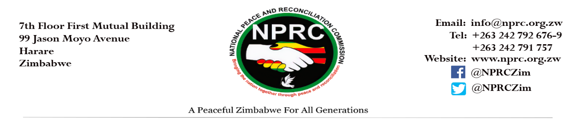2022 INTERNATIONAL WOMEN’S DAY STATEMENT
The National Peace and Reconciliation Commission joins the rest of the world in commemorating the 2022 International Women’s Day running under the theme: “Gender equality today for a sustainable tomorrow” # Breakthebias, recognising the contribution of women and girls around the world who are leading the change in climate change adaptation, mitigation and response to build a more sustainable future. The theme presents an opportunity for the NPRC to celebrate the critical role that women and girls play in fostering peace and social cohesion at both local and national level through climate change action as a conflict prevention mechanism.

In the wake of escalating climate and environmental crises and conflicts, the theme is pertinent to Zimbabwe and in particular to the NPRC’s conflict prevention mandate. Climate change is a threat multiplier that can accelerate tensions into conflicts especially in contexts where there are pre-existing vulnerabilities and patterns of discrimination against women and girls.

Conflict related Gender Based Violence also increases during emergencies due to the strife and stresses that are brought about by such situations, and there is often discrimination and marginalisation of women following conflict induced displacements. A prevention-oriented approach in resilience building for communities affected by climate change and emergencies induced conflicts is therefore key to strengthen the protection and empowerment of women thus, enhancing local capacities for peace.
The NPRC therefore calls upon all relevant stakeholders to-;
- Empower women and girls to have a voice and be equal players in decision-making related to climate change and sustainability as precursor for sustainable development, peace and greater gender equality. Evidence suggests that when women participate in peacebuilding and conflict prevention, sustainable peace outcomes are achieved.
- Develop and implement strategies that result in more resilient societies where rural women are safe from climate change and emergencies induced conflicts and other vulnerabilities. The empowerment and promotion of women’s participation in responding to conflict and emergency situations, promotes women’s resilience and coping mechanisms, thus ensuring conflict prevention.
- Accelerate the development of UNSCR 1325 National Action Plan. The United Nations Security Council Resolution 1325’s four pillars namely; Prevention, Protection, Protection and Relief and Recovery provide a comprehensive framework for addressing and responding to the inextricably linked; Gender, Climate Change, Peace and Security issues.
- Strengthen conflict related SGBV prevention and protection mechanisms following climate change induced disasters.
- Ensure that programmes supporting the implementation of national climate adaptation and mitigation strategies harness local knowledge and capacity of primary users of natural resources, including women, indigenous groups and other marginalized communities. Indigenous knowledge systems are key for sustainable development and sustainable peace outcomes.

PEACE BEGINS WITH ME, PEACE BEGINS WITH YOU, PEACE BEGINS WITH ALL OF US

Issued by NPRC

Date: 8 March 2022

