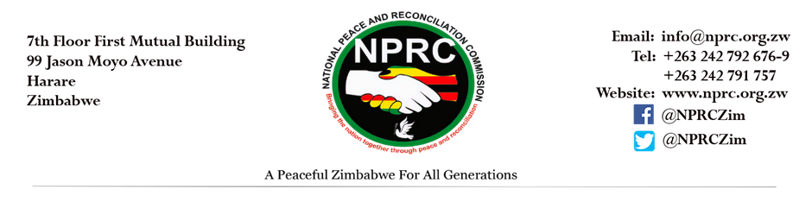
REQUEST FOR QUOTATION
The National Peace and Reconciliation Commission invites all PRAZ registered companies to make a firm offer for the provision of the following services:
Procurement reference number | Description of Requirements | Quantity | Closing date and time
NPRC11/2022 | We kindly request your office for vehicle service for Nissan NP300 AFG 2363:  - B service @ 80,000km | 1 | 14 NOVEMBER 2022 at 1100hrs

Commercial terms
- BIDDERS MUST HAVE CURRENT (2022) PRAZ REGISTRATION CERTIFICATE AND MUST SUBMIT IT (FAILER TO SUBMIT THIS IS AUTOMATIC DISQUALIFICATION)
- Bidders must have ZIMRA registration and must submit tax clearance and VAT certificate
- Bidders must have a vendor number and must confirm in their submissions that they have it.

The quotations must be submitted via email to rjojo@nprc.org.zw; mchinyadza@nprc.org.zw
Any quires kindly contact the Manager PMU Mrs R. JoJo on above Email.

