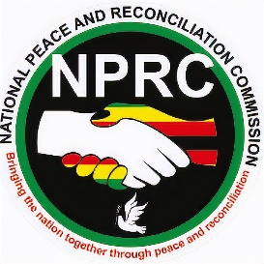
VICTIM SUPPORT, GENDER AND DIVERSITY
INTERNATIONAL WOMEN’S DAY, 08 MARCH 2023
MEDIA STATEMENT
The National Peace and Reconciliation Commission (NPRC) joins the world in commemorating the International Women’s Day, which is running under the theme; DigitALL: Innovation and technology for gender equality. The advancement of information, communication and technology has ushered in a new era of information sharing and dissemination around the world with ease. The internet and other Information Communication Technology have provided women and girls with platforms to receive education, engage with peers and express their own opinions.
Social media has been an important tool for women and girls to add their voice on issues of inclusion in peace-building and decision-making processes. However, the digital boom has brought about challenges which continue to hinder women’s effective participation in peace and decision making as cyber-bullying, hate speech, body shaming, use of derogatory language and online sexual harassment of women in general and female political actors in particular has been prevalent.
As the National Peace and Reconciliation Commission, we discourage all forms of cyber bullying and encourage positive use of technology and social media as they remain powerful tools for women and girls at all levels to engage in peacebuilding, conflict prevention and social cohesion.
Peace begins with Me, Peace Begins with You, Peace Begins with All of Us.

Inserted by: NPRC
Date: 7 March 2023

